Ottawa Carleton Institute for Electrical and Computer Engineering

School of Electrical Engineering and Computer Science

University of Ottawa

ELG-5383

Survivable Optical Networks

Assignment #1 Due February 9th, 2015

1) Devise the self-routing scheme for the 8x8 Banyan network and shuffle exchange network.

2) Consider the banyan network shown in Figure 1 with two packets applied to inputs 0 and 4 destined to outputs 6 and 5 respectively. Show that there is an internal blocking that has occurred and explain how to use deflection routing to remove this blocking. Show how to use bridged shuffle exchange networks along with deflection routing to further reduce the probability of blocking in banyan networks.

3) Calculate the total insertion loss in the network shown in Figure 2, assuming N=8, the fiber-to-waveguide loss W=1.5 dB, the excess loss in each 1:2 passive splitter and 2:1 combiner E= 0.3 dB, the insertion loss in a directional coupler L=0.5 dB. Assume also that the network is fabricated on a single substrate, the splitters and the combiners are implemented as binary trees, and that the propagation, crossover, and bending losses are negligible.

Fig. 2

Fig. 1

Inputs

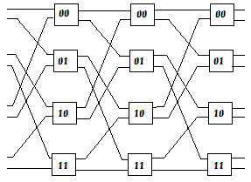

Outputs

Inputs

Fig. 1

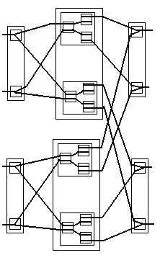

**1**

**1**

**1**

**1**

**1**

**1**

**N/2**

**N/2**

**N/2**

**N/2**

**N/2**

**2**

**2**

**N-1**

**N-1**

**N**

**N**

**...**

**...**

**...**

**...**